Day | 8:45 -9:30 | 9:30 - 9:50  Circle Time | 9.45-10:30 | 10:30-10:45 | 10:45-11:45 | 11:45 – 12:00  Circle Time | 12:00-1:20 | 1:20-1:25 | 1:25-1:35  Circle Time | 1:35-2:30 | 2:30 | 2:45
Monday | Arrival- Hang up coats and bags, Register, glasses on, BAHA’s on, SI Plans, brushing teeth, breakfast. Free flow learning begins | Wake & Shake/ Good Morning Song / Bucket / Phonics | Jobs / Free Flow Learning  Library | Wash hands/Snack Time | Free Flow Learning / Toilet | Song Time | Lunch Time / Outside Time | Register / Good afternoon Song | Story Time | Jobs / Free Flow  / Ball pool  Toilet | Afternoon Playtime Outside | End of day songs / Home time
Tuesday  (JP / BG) |  | Wake & Shake/ Good Morning Song / Bucket / Phonics | Messy Play / Free Flow Learning |  | Messy Play with Julie / Toilet  Patch | Understanding the world |  |  | Woodland Learning with Becky | Jobs / Free Flow  Toilet
Wednesday |  | Wake & Shake/ Good Morning Song / Bucket / Phonics | Jobs / Free Flow Learning / Library |  | Free Flow Learning / Toilet  Sensory Room | Concept: Same & Different |  |  | Understanding of the World | Jobs / Free Flow/ Ball Pool  Toilet
Thursday |  | Wake & Shake/ Good Morning Song / Bucket / Phonics | Jobs / Free Flow Learning |  | Free Flow Learning / Toilet | Numbers |  |  | The Big Write! | Jobs / Free Flow/ Ball Pool  Toilet
Friday |  | Wake & Shake/ Good Morning Song / Bucket / Phonics | Jobs / Free Flow Learning  Soft Play |  | Free Flow Learning / Toilet  Ball Pool | Yoga |  |  | Feeling Fabulous Friday activity/ PECs Club with Christine | Jobs / Free Flow Sensory Room  Toilet
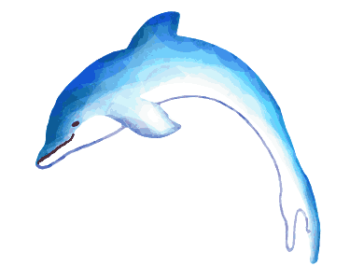

Other sessions:
At the Patch: UTW/PD/PSED
TA to take two children during each session. Discuss health and safety whilst walking to the Patch. Pupils should be given the opportunity to visit the chickens (including digging for worms), pick fruit and vegetables and water plants. Use In the Moment Planning to support and extend learning.
The Library: L/CL/PSED
TA to take children two at a time to the Library to choose a new book to take home. Adults to spend time sharing a story and modelling book behaviours. Take book bags and chn’s reader cards to sign books out.
The Sensory Room: PD/EAD/UTW/PSED
TA to take a group of children to explore the resources, allow children the opportunity to select their preferred areas. Make observations on Tapestry and use In the Moment Planning to support and extend learning.
The Ball Pool: M/PSED/UTW/CL/EAD
TA to take a small group to the ball pool and explore the resources, allowing chn to lead their own learning. Adults to use In the Moment Planning to support and extend learning.

